**Life Cycle of a Thread In JAVA**

In Multithreading, Thread can be in one of the five states which forms life cycle of the Thread. This life cycle of a thread is controlled by java virtual machine (JVM).

Following are the five stages by which Thread goes through in its lifecycle as shown in figure 1.1 :

1. New
2. Runnable
3. Running
4. Non-Runnable (Blocked)
5. Terminated

[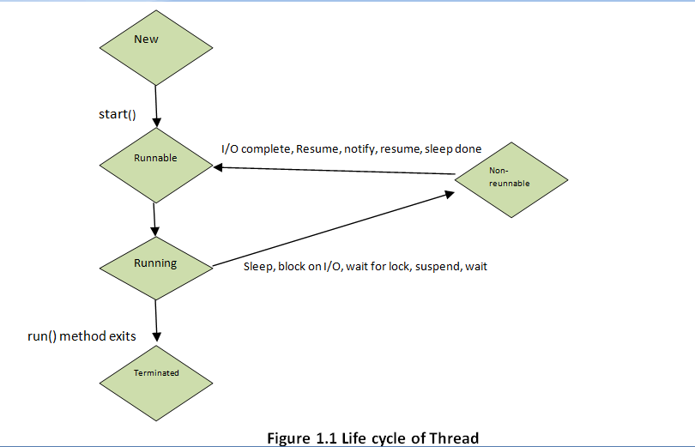](http://abhiandroid.com/java/wp-content/uploads/2016/04/LifeCycleOfThread-1.png)

**Let us discuss each Stage in Detail One by one:**

**1. New**

In this stage thread is referred to as a born thread. A new thread starts its life cycle in this stage. The thread remains in this thread until programs starts the thread.

**2. Runnable**

After a newly born thread is started , the thread comes in this stage which is referred to as runnable. The thread comes into this stage after calling start() method, Thread scheduler sets it to be runnable.

**3. Running**

Thread is in running stage only when Thread Scheduler has selected it. It executes all the tasks assigned to it in this stage.

**4. Non-Runnable (Blocked)**

In this stage, Thread is still alive but it is not eligible to run due to some condition. In this stage thread is referred to be in waiting stage.

**5. Terminated**

Thread is terminated when its run() method exists. In this stage thread is referred as Dead thread.